**HOMEWORK: How to Measure Your Room**

A successful layout is dependent on balance and scale and one of the best ways to achieve this is by creating a drawing of your space. This allows you to visualize how your furniture and decor will fit together and helps you avoid making costly mistakes. We will be doing this together on your weekend.

It is important to keep in mind that not all furniture is created equal, and what worked in your previous home may not work in your new space. Too many of us make the mistake of bringing our old furniture to our new home without considering whether it is a good fit for the new space. This can lead to a cluttered and unbalanced layout that does not optimize the potential of the room.

Overall, creating a floor plan view can be a fun and useful way to visualize the layout of a space. With a bit of planning and attention to detail, you can create a detailed and accurate floor plan that will help you better understand the space and make the most of it.

FLOOR and CEILING

1. You will start by measuring the size of the room. We will be drawing the room tomorrow but if you could use the attached Floor and Ceiling Diagram handout as a reference. This diagram is from the top-down view looking at the floor and up to the ceiling. We are using the same diagram for both floor and ceiling because they are usually the same size. Your room may be different.
   1. Start with the longest wall. It may be helpful to have another person for this step, but if you can’t get help, that’s ok.  You can do this by yourself. Lay the measuring tape on floor along the baseboard. You may need to move some furniture out of the way. If you can’t move the furniture, you can measure across the middle of the room to get the length of the room. Write down the measurement from wall to wall as the “Full Length” measurement (nearest ¼”).
   2. Do this again with the “Full Width” measurement

*If you room is L shaped then measure both the long width and the short width and the long length and the short length. It may be helpful to alter your diagram into an L shape by crossing off a small section so the diagram looks more like your room.

*If you have an angled wall, measure both the long width and the short width at the two ends of the angled wall.

WALLS

1. You may have more than 4 walls if your room isn’t a simple rectangle. Please use the number of copies you need of the “Wall Diagram” to record your measurements. Do not measure any windows or doors at this time.
   1. Start with the longest wall. If you don’t have another person to help you, you can lay the measuring tape on the floor along the baseboard. The goal is to get the measurement of the wall from corner to corner to the nearest ¼”. Indicate that measurement as the “Full Width” measurement on the diagram.
   2. Do this again with the “Full Height” measurement measuring from the corner where the wall meets the floor to the corner where the wall meets the ceiling.

OPENINGS

1. Where the openings are located on a wall can affect the placement and the size of furniture chosen. Therefore, we need to measure the openings and the placement of those openings on the wall. IMPORTANT NOTE: Be careful not to measure to the molding but to the actual opening.
   1. Measure the height and width of each opening to the ¼” and indicate on the diagram. This is a good time to mark which way the door opens if you are measuring a door opening
   2. Then measure the distance from the opening to each of the 4 corners or to the nearest obstruction.
   3. Continue going around the room repeating steps a. and b. for each opening and indicate those measurements.
   4. Indicate the width of the window and door moldings in the area provided.

BUILT-IN FEATURES/OBSTRUCTIONS

1. I am referring to built-in features that jut into the room. Some examples of a built-in feature would be an archway opening, a fireplace and a cabinet.
   1. Now measure the built in features.
   2. Measure the height, width and depth of each feature
   3. Then measure the distance from each built-in to each of the 4 corners or to the nearest obstruction/opening.

HVAC & ELECTRICAL

1. The location of Heating, Air Conditioning vents, and Electrical outlets, switches, thermostats, radiators are nice to know. These can be indicated on your plan as well. A simple “S” for switch or “O” for outlet to indicate the locations are helpful. I do like to draw in the radiators since they are not in the wall but actually sit inside the room. Measure the entire width including the pipe that usually extends past the radiator itself since that space is not usable space.
2. Now we measure and mark where the vents are in the room and the switches and outlets.  This may seem unnecessary when all you want to do is place furniture but I can’t tell you how many times I have had to deal with trying not to block air vents when trying to figure out a layout. It is good to know where they are and how to keep the air flow free of obstructions. Same with switches. We don’t want to put a bookcase in front of a light switch. I don’t mind covering up outlets but I do want to know how far my cord has to be to get to the nearest outlet if I put a lamp in the middle of the room.
   1. Generally, at this time, it isn’t necessary to know the exact location of the outlets on the wall but only the general location. The easiest way to do this is to just draw the outlets on your diagram. The outlets are indicated by this symbol. Indicate the general location of all your outlets on your diagram.
   2. HVAC vents usually have a vent cover. Treat the HVAC vent cover the same as an opening. Please follow step 3 for all HVAC vent covers in the room and indicate the measurements.
3. Lastly, to prepare for our exercise together, think about what furniture you really love and want to use again in this room. List those pieces and measure the length and width of each.

_____________________________________________________________

_____________________________________________________________

_____________________________________________________________

______________________________________________________________

The drawing below is

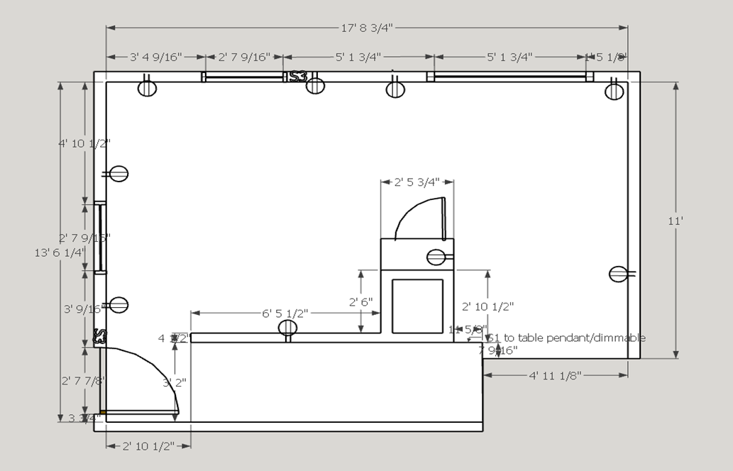

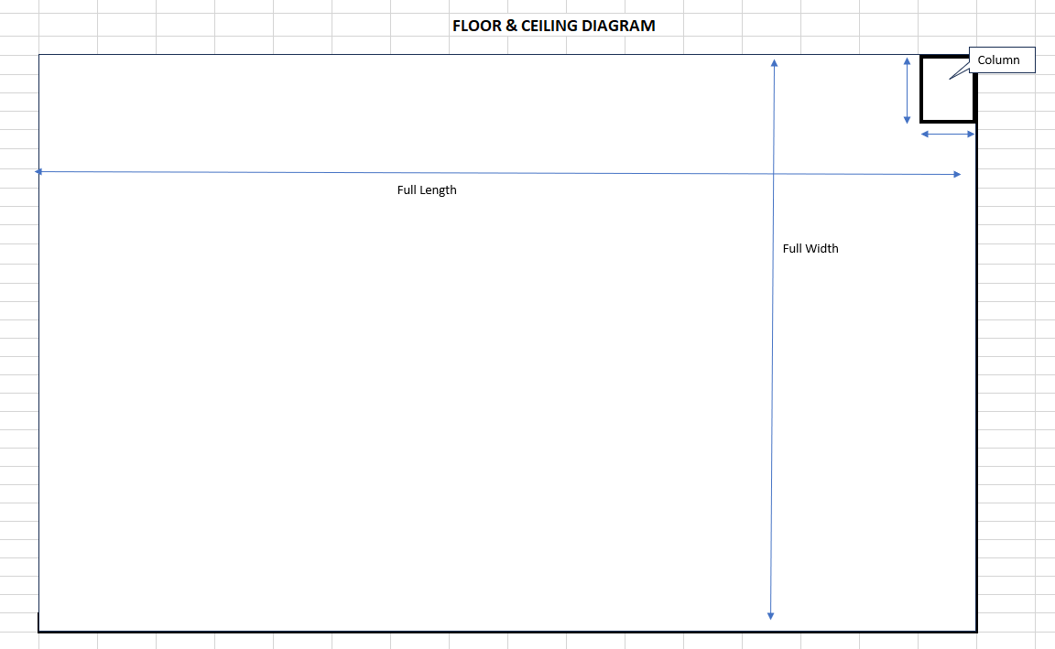

Full Room Width ____________

Full Room Length _____________

Obstruction Depth _________

Obstruction Depth _________

_____________________________

_____________________________

_____________________________

_____________________________

_____________________________

_____________________________

_____________________________

_____________________________

_____________________________

_____________________________

_____________________________

_____________________________

_____________________________

_____________________________

_____________________________

_____________________________

_____________________________

_____________________________

_____________________________

_____________________________

Please fill in the appropriate measurements and confirm that the measurements add up to the

full room width and full width length. If the calculated measurement does not match, remeasure

widths until the *calculated full room width measurement* matches your measured width.

Opening Width __________

+ Opening to Right __________

+ Opening to Left ____________

+ 2nd Opening Width __________

+ 2nd Opening to Right __________

+ 2nd Opening to Left __________

____________________________________

= Calculated Full Room Width __________

Opening Width __________

+ Opening to Right __________

+ Opening to Left ____________

+ 2nd Opening Width __________

+ 2nd Opening to Right __________

+ 2nd Opening to Left __________

____________________________________

= Calculated Full Room Length __________

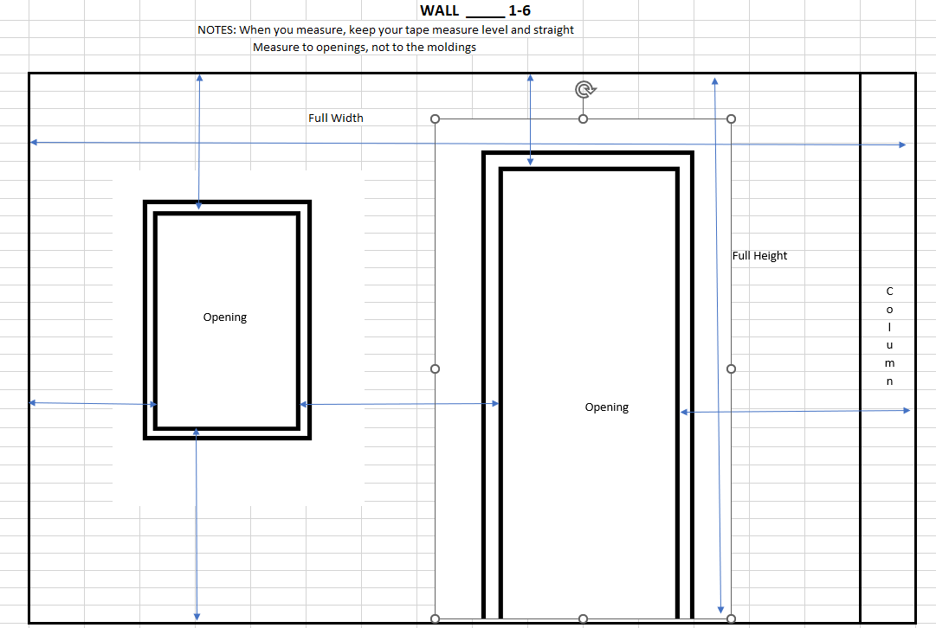

Width of Window and Door Moldings __________

Full Wall Width ____________

Window Opening Width _________

Window Opening to left __________

Window Opening to right _________

Door Opening Width ____________

Door Opening to left ____________

Door Opening to right ___________

_____Opening Width ____________

_____Opening to left ____________

_____Opening to right___________

_____________________________

_____________________________

_____________________________

Full Wall Height _____________

_____________________________

Door Opening Height ___________

Door Opening to Ceiling _________

Window Opening Height _________

Window Opening to Ceiling _______

Window Opening to Floor ________

_____________________________

_____________________________

_____________________________

_____________________________

_____________________________

_____________________________

_____________________________

_____________________________

_____________________________

_____________________________

_____________________________

_____________________________

_____________________________

_____________________________

_____________________________